Follow-up 1: Repeated Advice–Solo Blocks
Original Design:
In the initial version of the study, participants in AI conditions (AI Advisor, xAI Advisor, and dxAI Advisor) completed a single Advice block of 20 rounds, during which they received AI predictions for NFT prices, followed by a Solo block of 5 rounds with no AI advice. This was intended to measure performance and confidence both with and without AI advice.
Updated Design:
In the revised design, we propose splitting the task into two Advice–Solo cycles, each with fewer rounds. The new structure is:
- Participants: Randomly assigned to one of four conditions: Control, AI, xAI, dxAI (between-subjects factor: advisor type)
- Task Structure (within-subject factor: advice status, cycle, trial within block):
  - Block 1: Advice (10 rounds)
  - Block 2: Solo (5 rounds)
  - Block 3: Advice (10 rounds)
  - Block 4: Solo (5 rounds)
- Control condition: Perform all trials solo
- AI conditions: Receive advice (with or without explanation) during Advice blocks
- Unit of observation: trial-level (each round), aggregated to blocks for summaries
- Goal: Examine how trust, reliance on AI, and accuracy evolve over repeated exposure and removal of AI advice.
Rationale:
Splitting the task into repeated Advice–Solo cycles allows observation of temporal dynamics: persistence of trust, recalibration of reliance on AI, and retention of predictive accuracy.
Dependent Variables:
- Weight of Advice (WoA): Adjustment toward AI advice, [0,1].
- Absolute Prediction Error (APE): Accuracy normalized to true price.
- Secondary measures: Self-reported trust, self-reported adjustment, postTrain_perf, explanation satisfaction (xAI/dxAI).

Hypotheses:
Trust Dynamics:
- H1a (DV: WoA): Initial trust boost (rounds 1-5 of Advice1) will replicate original finding (xAI ≥ AI > Control) – replicating original H1
- H1b (DV: WoA decay slope): Trust will erode faster for dxAI than other advice types – replicating original H2
Learning Transfer:
- H2 (DV: APE): AI-supported conditions < control during Advice blocks – replicating & expanding original H3
- H3 (DV: APE retention): xAI participants outperform others in Solo blocks – replicating & expanding original H4

Analysis Plan:
- Linear mixed-effect models (LME) for WoA:
- Goal: Examine how trust in AI (behavioral reliance on advice) changes over time, across blocks and conditions.
- Proposed Model: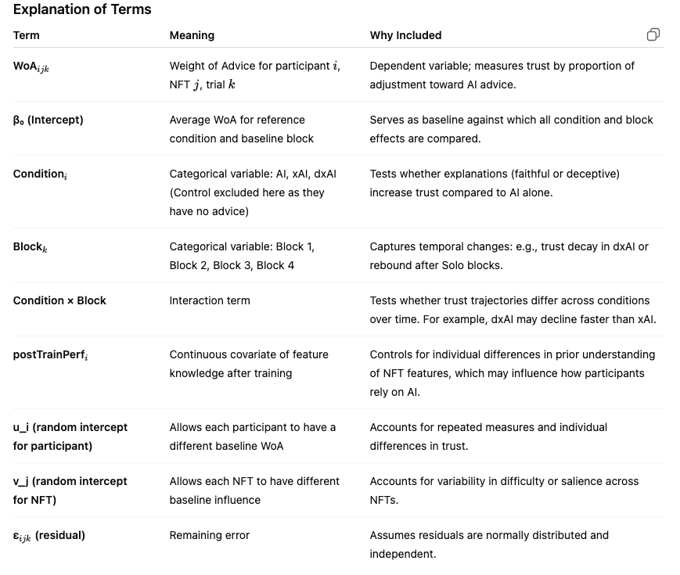
- Random effects:
  - Intercept + trial slope by participant (u_i)
  - Intercept by NFT (u_j)
  - ε_ijk​ (residual remaining error)
- Planned contrasts:
  - H1a: xAI > AI; dxAI > AI at Block 1
  - H1b: dxAI slope < xAI slope
  - H2: Solo 2 APE: (xAI <= AI<= dxAI) < Control
  - H3: xAI Solo block APE < other conditions
Visualization: Line plot of WoA across trials/blocks by condition.
Interpretation of Interactions
- Condition × Block:
  - Positive coefficient: the increase in WoA in a block is larger for that condition relative to reference.
  - Negative coefficient: the increase (or maintenance) in WoA is smaller; e.g., dxAI trust decays faster than xAI over time.
- Main effects of Condition:
  - Tell us whether xAI or dxAI are trusted more than AI at baseline (Block 1).
- Main effects of Block:
  - Tell us whether WoA changes across blocks for the reference condition (e.g., does trust naturally decay without interaction?)

- Linear mixed-effect models (LME) for APE:
- Goal: Examine accuracy differences across conditions and over time, including the retention of learning in Solo blocks.
- Proposed Model
- Dependent variable: APE (lower values indicate better performance).
- Condition: Controls for AI advice type.
- Block: Captures temporal dynamics, including Solo blocks where no advice is given.
- Condition × Block: Tests whether, for example, xAI participants retain lower APE in Solo blocks (H3).
- Random effects same as WoA model.

Interpreting coefficients:
- Main effect of Condition: initial difference between AI types.
- Main effect of Block: average change across blocks.
- Interaction: differential change over time by condition (critical for H1b and H3).

